ETH Zürich

IDSC

Professor Emilio Frazzoli

Zürich Autonomous Race Car Assembly Instructions

The following document includes assembly instructions for the Zürich Autonomous Race Car (ZARC). All software can be found on the ZARC GitHub repository [here](https://github.com/idsc-frazzoli/zarc). The guide is intended to include all directions needed in order to reproduce a working ZARC platform. The guide is divided into three parts:

* Bill of materials (BOM)
* Flashing the Odroid and installing ROS
* Chassis assembly
* Electrical assembly

**BILL OF MATERIALS**

**Chassis and mount deck**

|  |  |  |  |
| --- | --- | --- | --- |
| **Component** | **Vendor** | **Quantity** | **Location** |
| 1x 1/10th scale Traxxis Rally RC car | Traxxis | 1 | [here](https://traxxas.com/products/models/electric/ford-fiesta-st-rally?t=overview) |
| Custom ZARC mount deck | - | 1 | zarc/CAD repo |

**Microcontrollers and Accessories**

|  |  |  |  |
| --- | --- | --- | --- |
| **Component** | **Vendor** | **Quantity** | **Location** |
| Odroid XU4 | Ameridroid | 1 | [here](https://ameridroid.com/products/odroid-xu4) |
| Odroid XU4 Case | Ameridroid | 1 | [here](https://ameridroid.com/products/xu4-case-top-half-black-0133) |
| 5V 3A Power supply | Ameridroid | 1 | [here](https://ameridroid.com/products/5v-3a-power-supply) |
| Odroid XU4 eMMC storage 64GB and eMMC to microSD adapter | Ameridroid | 1 | [here](https://ameridroid.com/products/64gb-emmc-50-module-xu3-linux) |
| Transcend USB 3.0 microSD card reader | Amazon | 1 | [here](https://www.amazon.com/Transcend-microSDHC-Reader-TSRDF5K-Black/dp/B009D79VH4) |
| Odroid XU4 Real-Time-Clock battery | Ameridroid | 1 | [here](https://ameridroid.com/products/rtc-battery) |
| Arduino Nano w/ micro USB to  USB cable | Amazon | 1 | [here](https://www.amazon.com/SainSmart-Nano-black-Cable-Arduino/dp/B00CJ7EARG/ref=sr_1_1?ie=UTF8&qid=1460665174&sr=8-1&keywords=arduino%2Bnano%2Bblack&th=1) |
| 4 port USB hub | Amazon | 1 | [here](https://www.amazon.com/Sabrent-4-Port-Individual-Switches-HB-UMLS/dp/B00BWF5U0M/ref=sr_1_1?ie=UTF8&qid=1456792062&sr=8-1&keywords=usb+hub) |
| Odroid Wifi Module 3 | Ameridroid | 1 | [here](https://ameridroid.com/products/wifi-module-3) |
| Odroid Wifi Module 5 | Ameridroid | 1 | [here](https://ameridroid.com/products/wifi-module-5) |
| Custom ZARC PCB | - | 1 | zarc/CAD repo |
| Buck Converter | Amazon | 1 | [here](https://www.amazon.com/RioRand-LM2596-Converter-1-23V-30V-Pcs-LM2596/dp/B008BHB4L8?ie=UTF8&dpID=41oDKWEa9RL&dpSrc=sims&preST=_AC_UL160_SR160%2C160_&refRID=01A7EJHEN8SAB2NJQ89D&ref_=pd_sim_422_2) |
| Anderson Powerpole Connectors | Amazon | 1 | [here](https://www.amazon.com/Anderson-Powerpole-Connectors-50-Pair/dp/B0070RUJ0M/ref=pd_sim_21_6?ie=UTF8&dpID=517wIhpeMoL&dpSrc=sims&preST=_AC_UL160_SR160%2C160_&refRID=1RAAPAWHKCJ9ZFP7ZXDF) |
| 18 AWG wire (red and black) | Amazon | 1 | [here](https://www.amazon.com/BNTECHGO-electrical-resistance-efficient-connection/dp/B01708AYYQ/ref=sr_1_1?s=lamps-light&ie=UTF8&qid=1473290746&sr=1-1&refinements=p_n_feature_keywords_browse-bin%3A3605500011) |
| Male pin headers | Amazon | 1 | [here](https://www.amazon.com/Single-40Pin-2-54mm-Header-Connector/dp/B00R1LEIL8?ie=UTF8&keywords=male%20header%20pins&qid=1452565257&ref_=sr_1_3&sr=8-3) |
| Female pin headers | Amazon | 1 | [here](https://www.amazon.com/Straight-Female-Header-Spacing-Connector/dp/B00TGOJE1W?ie=UTF8&dpID=51giDgngCCL&dpSrc=sims&preST=_AC_UL160_SR160%2C160_&refRID=1KSKJTP2V9XPRNW59K9B&ref_=pd_sim_147_6) |
| 24 AWG wire | Amazon | 1 | [here](https://www.amazon.com/Stranded-Length-0-0201-Diameter-UL1007/dp/B00N51OJNK/ref=sr_1_3?ie=UTF8&qid=1452565725&sr=8-3&keywords=stranded+wire) |
| Heat shrink tubing | Amazon | 1 | [here](https://www.amazon.com/gp/product/B00Q7V49RQ?psc=1&redirect=true&ref_=oh_aui_detailpage_o03_s00) |
| Electrical tape | Amazon | 1 | [here](https://www.amazon.com/gp/product/B00004WCCP?psc=1&redirect=true&ref_=oh_aui_detailpage_o08_s00) |
| Thread Locker | Amazon | 1 | [here](https://www.amazon.com/Loctite-Heavy-Duty-Threadlocker-Single/dp/B000I1RSNS) |

**Connectors**

|  |  |  |  |
| --- | --- | --- | --- |
| **Component** | **Vendor** | **Quantity** | **Location** |
| USB to micro USB (Odroid to IMU connector) | Amazon | 1 | [here](https://www.amazon.com/AmazonBasics-Male-Micro-Cable-Black/dp/B0711PVX6Z/ref=sr_1_1?s=electronics&ie=UTF8&qid=1516911379&sr=1-1&keywords=usb%2Bto%2Bmicro%2Busb&th=1) |
| Custom Male-Female connectors for RC control (please see the image/description of the custom connectors under the “electrical assembly” section for further details | - | 2 | - |

**Sensors and Accessories**

|  |  |  |  |
| --- | --- | --- | --- |
| **Component** | **Vendor** | **Quantity** | **Location** |
| Odroid myAHRS+ IMU | Ameridroid | 1 | [here](https://ameridroid.com/products/myahrs-attitude-heading-reference-system) |
| Hall effect sensors (it’s a good idea to order extras in case some break) | SparkFun | 4 | [here](https://www.sparkfun.com/products/9312) |
| Magnets for hall effect sensors | McMaster-Carr | 16 | [here](https://www.mcmaster.com/#5862k11/=ym68r3) |
| ZARC front wheel encoder mount | - | 2 | zarc/CAD repo |
| ZARC rear wheel encoder mount | - | 2 | zarc/CAD repo |

**Hardware** (available at your local hardware store)

|  |  |  |  |
| --- | --- | --- | --- |
| **Component** | **Vendor** | **Quantity** | **Location** |
| m3 x 20mm button head screw | - | 2 | - |
| m3 x 16mm button head screw | - | 2 | - |
| m3 x 12mm button head screw | - | 4 | - |
| m3 x 40mm threaded shaft | - | 2 | - |
| m3 nut | - | 4 | - |
| m3 washer | - | 4 | - |
| m2 x 16 button head screw | - | 6 | - |
| m2 x 3 button head screw | - | 2 | - |
| m2 nut | - | 6 | - |
| 5mm plastic spacer (for mounting custom ZARC PCB) | - | 4 | - |

**FLASHING THE ODROID AND INSTALLING ROS**

In order to flash the Odroid, please refer to the instructions provided in the original BARC documents (with one exception listed below the provided link):

<https://github.com/MPC-Berkeley/barc/blob/master/docs/FlashingEMMC.md>

Exception: The original BARC car ran Ubuntu 14.04, which is currently outdated. In order to find the most recent Ubuntu version for Odroid, please visit the following website:

<https://odroid.in/ubuntu_16.04lts/>

Download the latest LTS (long term support) version of Ubuntu Mate from the link above. As of this writing, the latest version is Ubuntu 16.04. Once correct image has been downloaded, please following the original instructions provided in the first link above to flash the Odroid.

After you have successfully flashed the Odroid, you will need to install your preferred release of ROS (Robot Operating System). A detailed guide on the available releases and installation instructions for each can be found on the ROS website here: <http://www.ros.org/>.

The ZARC Odroid currently runs ROS Kinetic (on Ubuntu), for which installation instructions can be found here: <http://wiki.ros.org/kinetic/Installation/Ubuntu>.

**CHASSIS ASSEMBLY**

The first step of assembling the ZARC platform is to remove the outer “shell” of the car so that you are able to view the chassis as seen below:

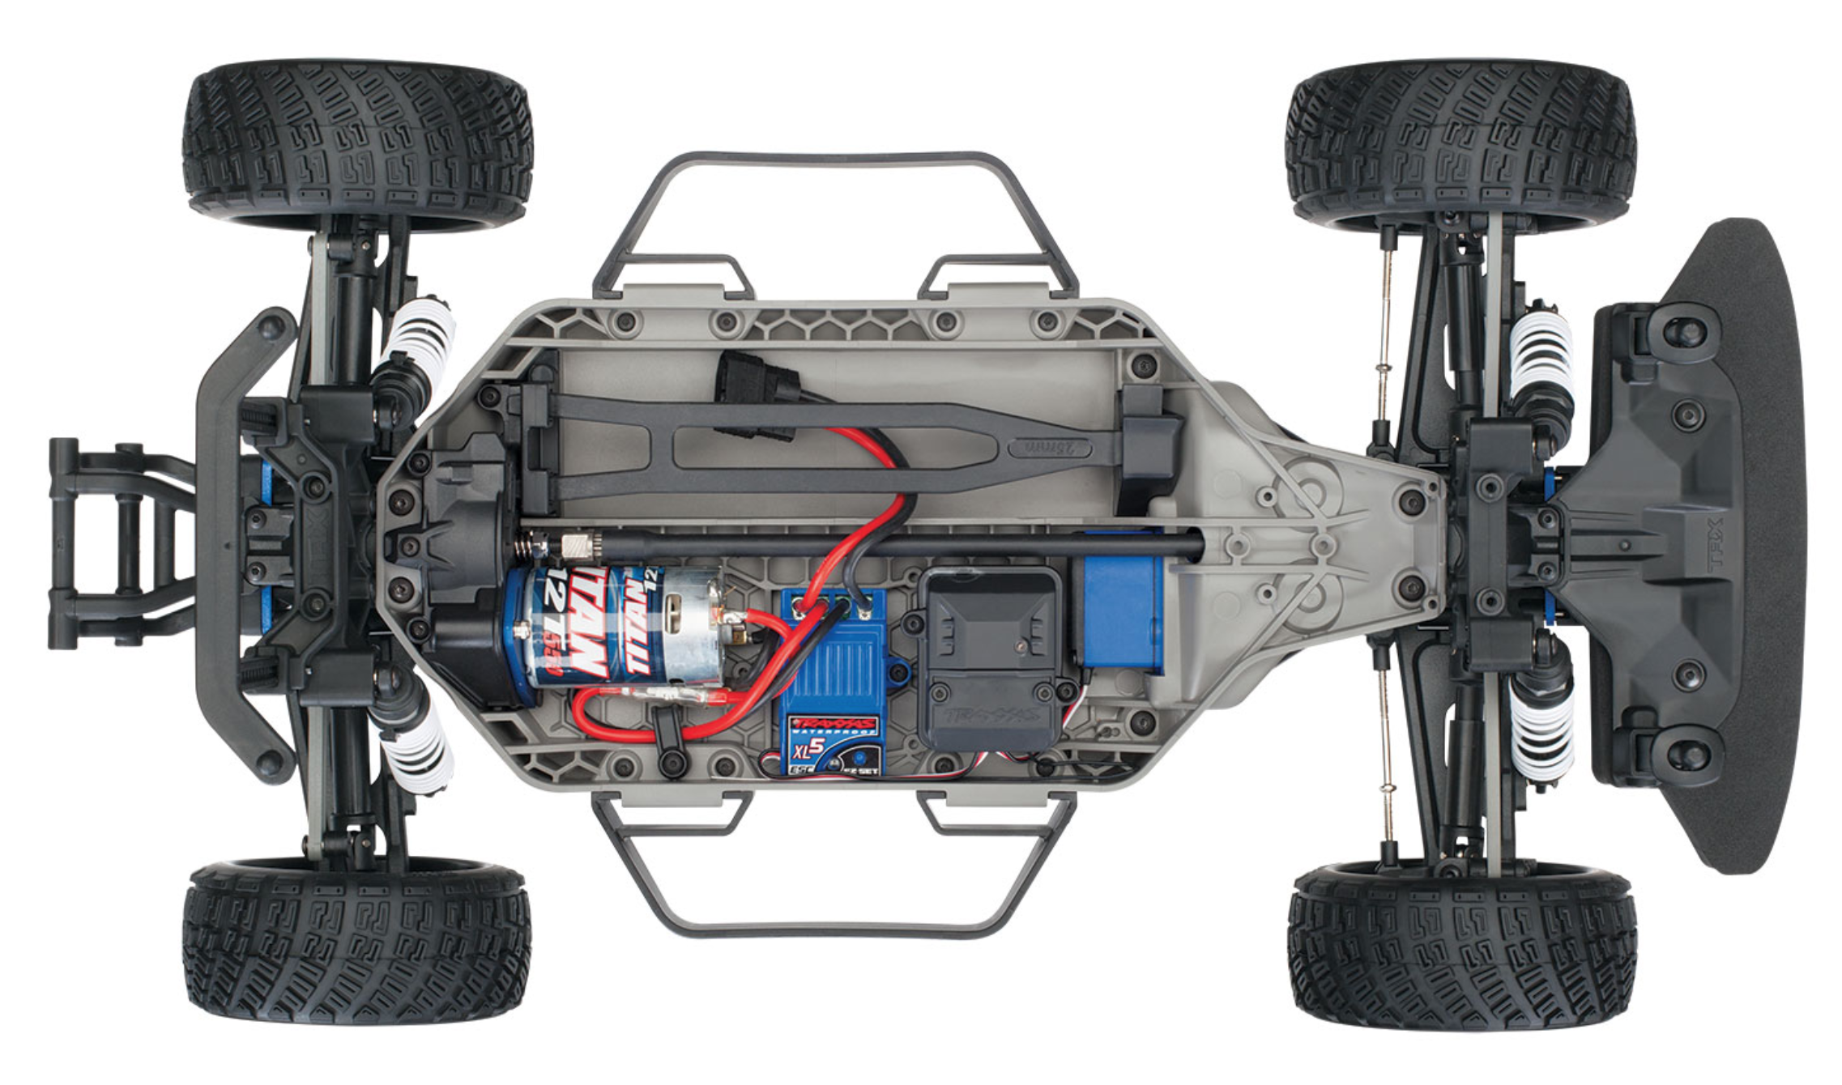

Traxxis RC car chassis

**Wheel encoders**

The following wheel encoder instructions are copied from the original BARC installation manual. To see the original manual in full, please navigate to the following document: [Original BARC Manual](Original%20BARC%20Manual)

1. Cut three pieces of wire, about 3cm each. Strip off about 0.5cm from each end. Cut the metal pins on the hall effect sensor to 0.75cm long. Cut a piece of 1x3 male pin header. See diagram below. Note: for the ZARC vehicle, the connector shown was extended in order to reach all the way to the Arduino with the male pin headers. As such the wires were roughly cut at a length of 30cm instead of 3cm as shown here. Please cut according to your own design considerations. To see how the ZARC encoder connectors look, please see the photo under step 5) in the “Hall sensor mounts” section below.

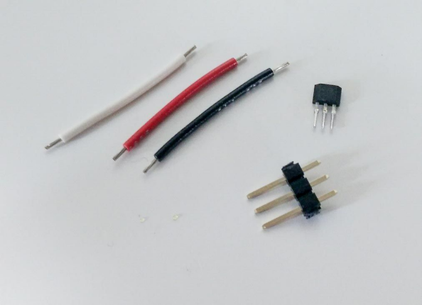

1. Solder the wires onto the pins of the hall effect sensor. It helps to tin the pins and wires before soldering them together. Beware of the polarity (see data sheet below). Use red for VDD, black for GND, white for SIG/OUT.

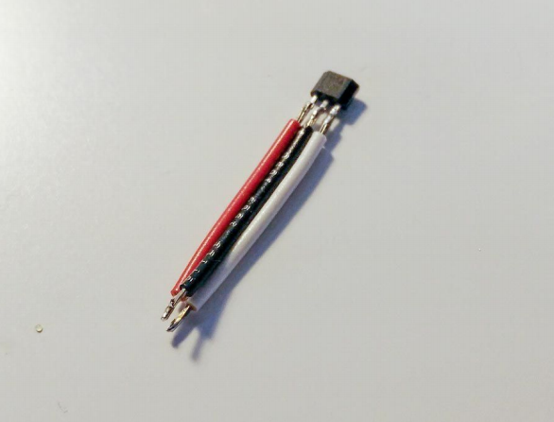

1. Hall effect sensor pin-out:

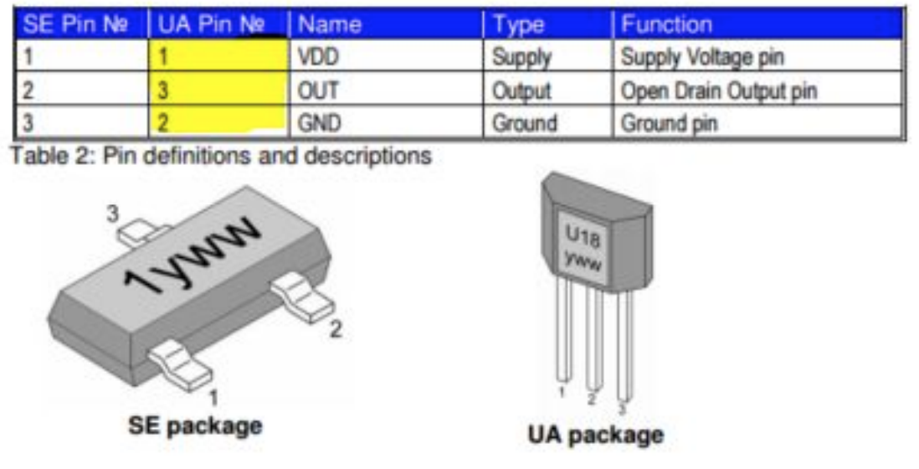

1. Insert heat shrink tubing over the solder joints and heat them with the neck of the soldering iron until they wrap snuggly over the joint. Use the thinnest heat shrink you can find (about 1mm after shrinking). No bare metal should be exposed from the joint.

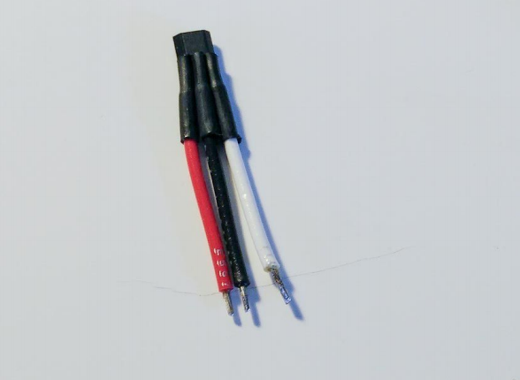

1. Insert another piece of heat shrink tubing on each wire. This is to prepare for the solder joint on the other side.

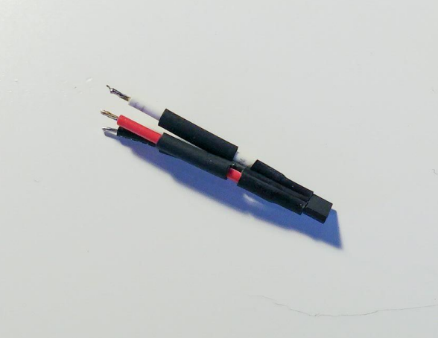

1. Solder the short side of the male pin header to the wires. Note the crossover between the red and black wire. Red should be in the middle at the pin header side. Push the heat shrink tubing over the solder joint and apply heat.

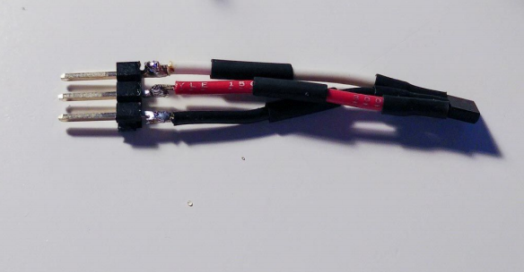

1. Use a piece of larger heat shrink tubing to wrap over the hall effect sensor and the three smaller heat shrinks (this will act as a strain-relief to protect the sensor pins).

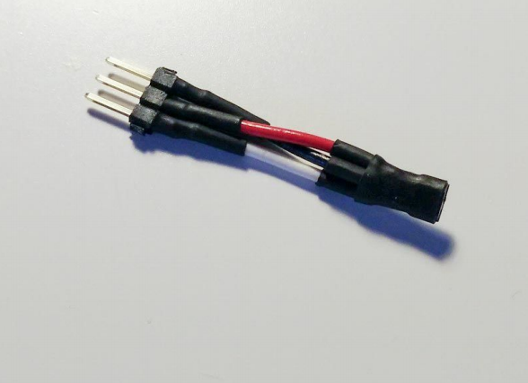

**Wheel encoder mounts**

The wheel encoder mounts are custom 3D printed parts (see the BOM for more details on where to obtain the mount design files to print on your own). The sensor mount instructions are divided into the front and rear mounts. Each front and rear set of instructions must be repeated for the other side of the car.

**Front wheel encoder mount**, required hardware (repeat for other side):

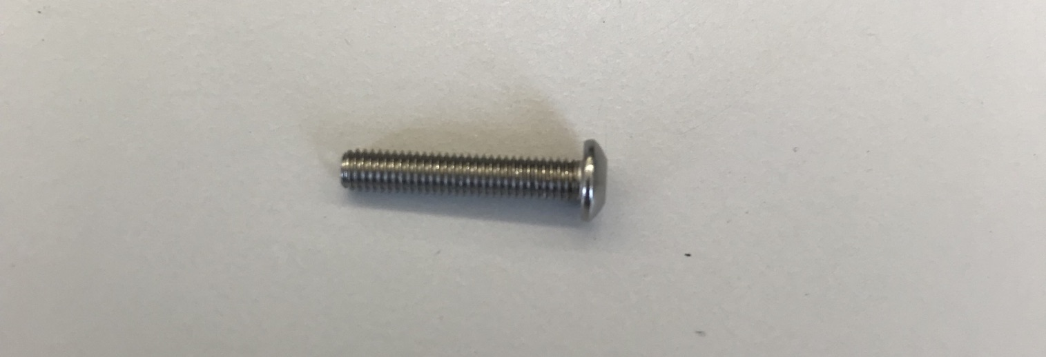

1x m3x16mm button head screw

1. Remove the front wheel lock nut with a 7mm socket.
2. Remove factory hardware that secures the tie rod to the front wheel hub assembly.
3. Glue (using hot glue) the hall effect sensor into the slot of the mount as shown in the figures below.
4. Snap the front wheel encoder mount into place as shown below (notice the front tie rod has been removed as described in 2).

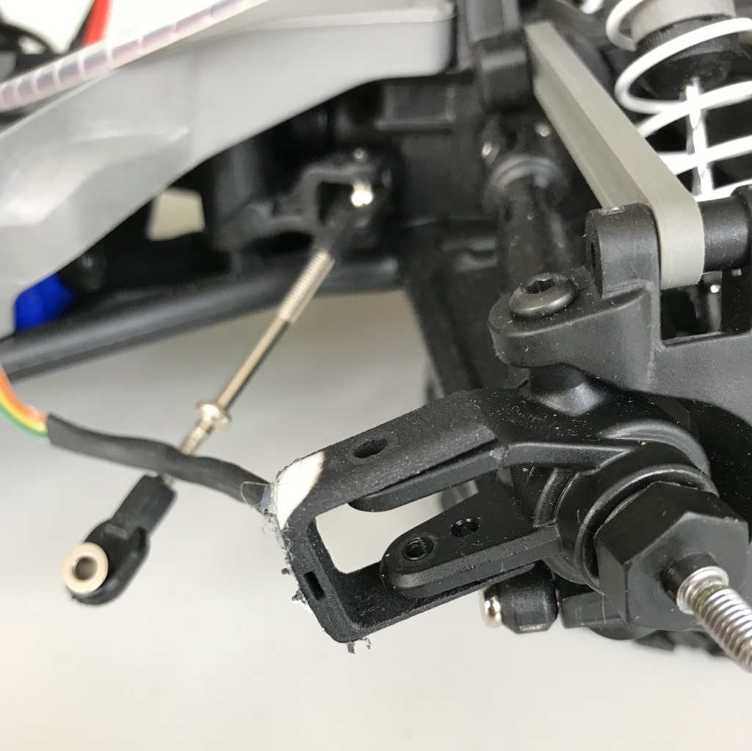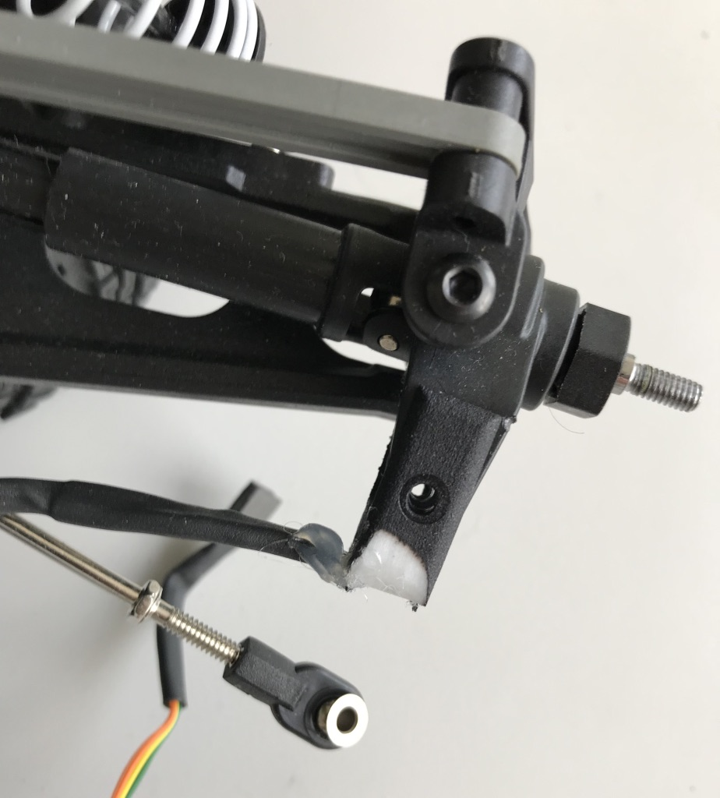

Side view and top view, respectively, of the front hall sensor mounts

1. Secure the front wheel encoder mount into place with 1 m3x16mm screw as shown below.

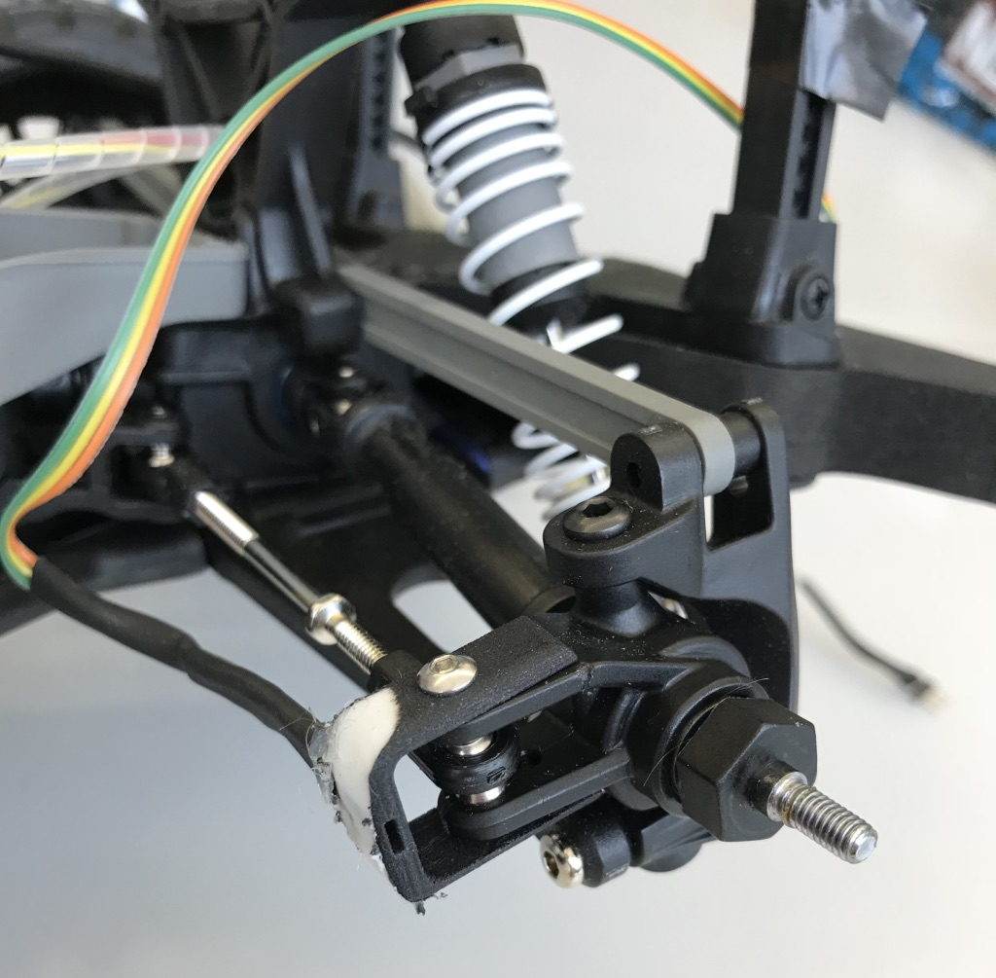

1. Re-install the wheel, again using a 7mm socket to secure the lock nut.

**Rear wheel encoder mount**, required hardware (repeat for other side):

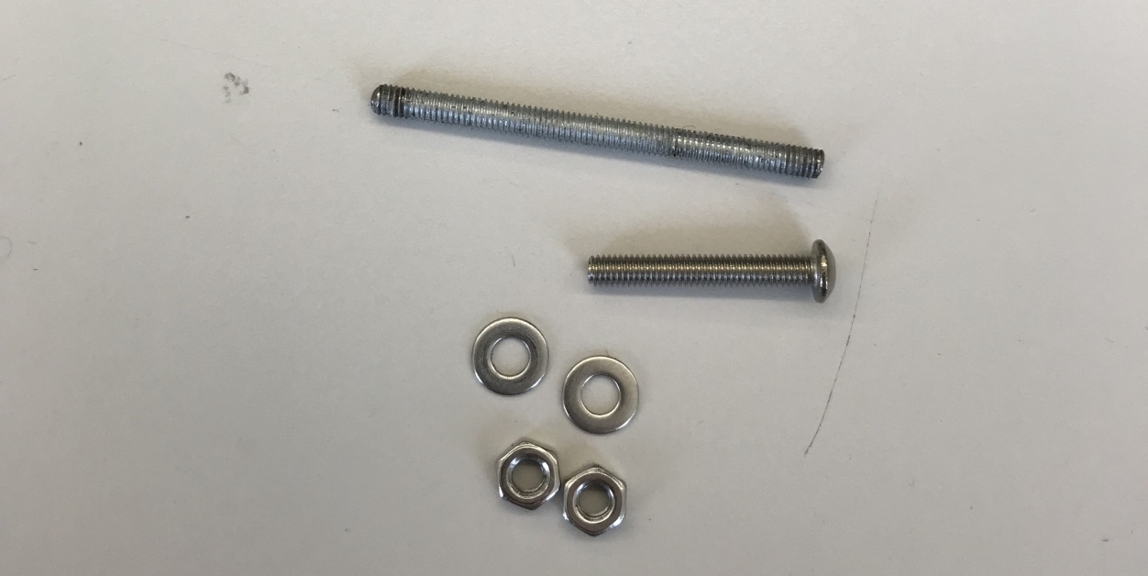

1x m3x20mm button head screw

2x m3 nut

2x m3 washer

1x m3x40mm threaded shaft

1. Remove the rear wheel lock nut with a 7mm socket.
2. Remove factory hardware that secures the rear wheel hub assembly.
3. Glue (using hot glue) the hall effect sensor into the slot of the mount as shown in the figure below.

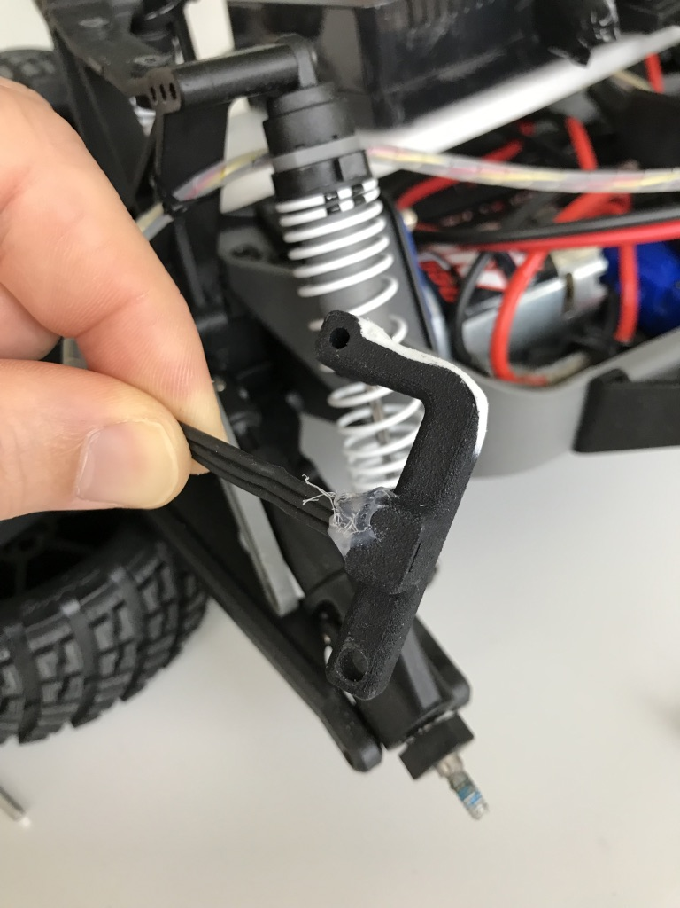

1. Thread 1 m3x20mm screw into the upper wheel encoder mount point as shown in the left image below.

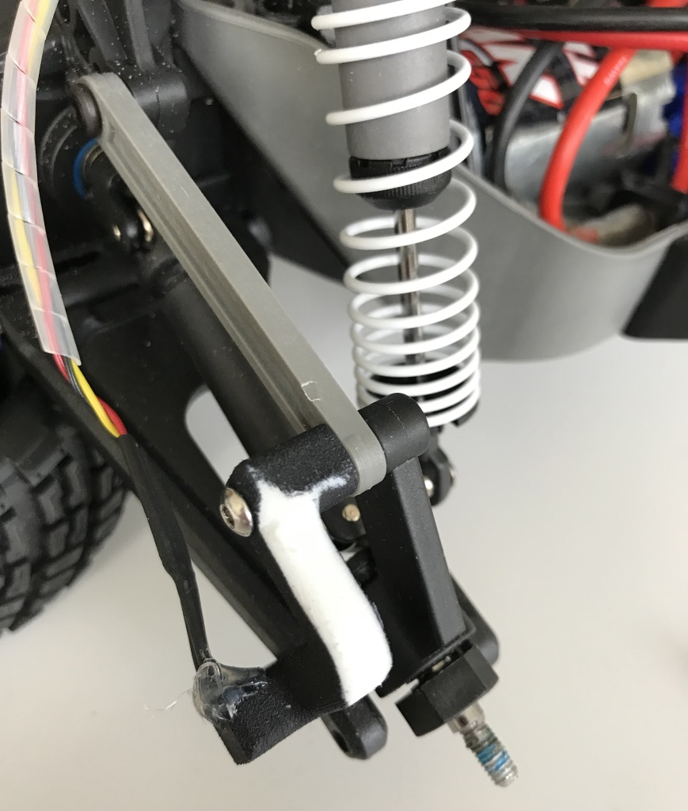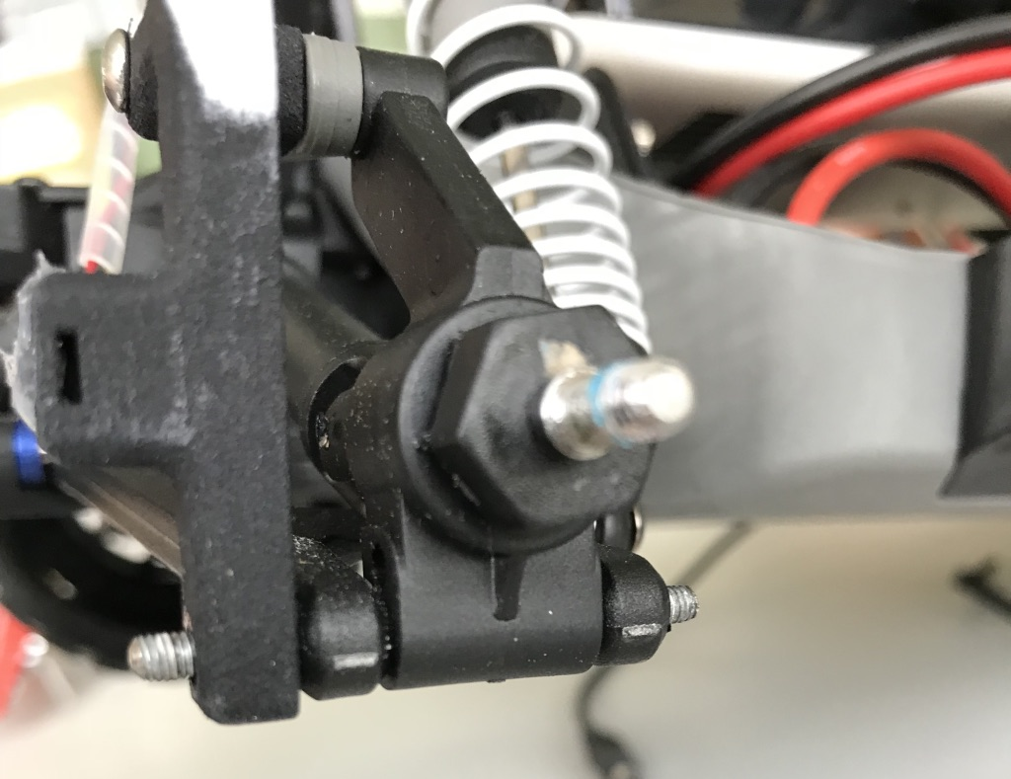

1. Insert the m3x40mm threaded shaft into the lower wheel encoder mount point as shown in the right image above.
2. Using the m3 5.5mm nuts and m3 washer, secure the lower wheel encoder mount threaded shaft as shown below. It is advisable to use some thread locker to ensure the nuts stay in place.

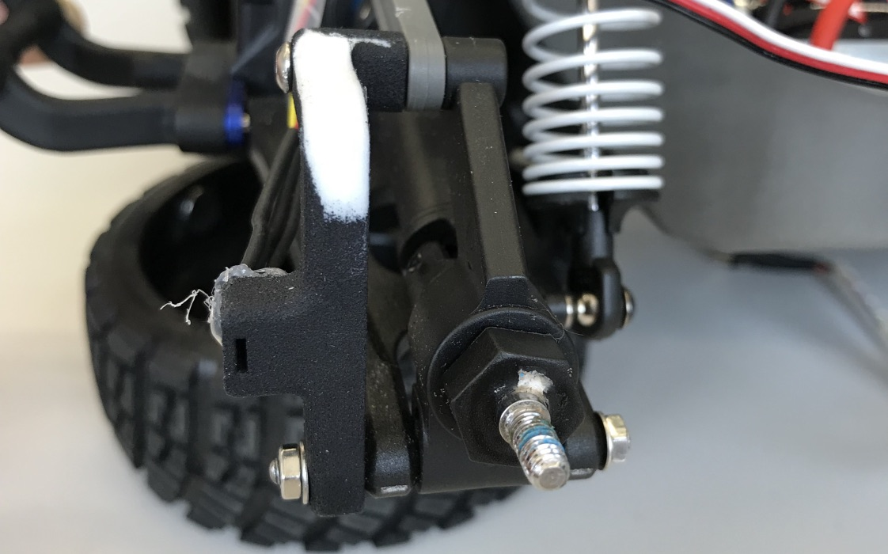

1. Re-install the rear wheel, again using a 7mm socket to secure the lock nut.

**Wheel Encoder Magnets**

Glue (with hot glue) the magnets to the inside of each wheel (x4) with the correct polarity as shown below. Ensure the magnets are installed with the correct polarity at uniform ¼ increments along the inner circumference of the wheel.

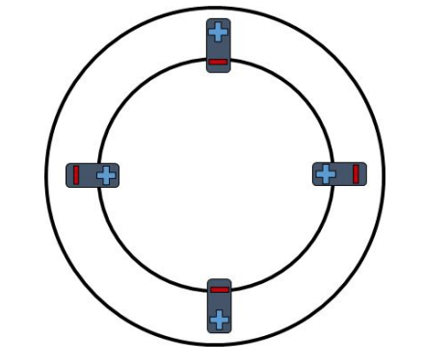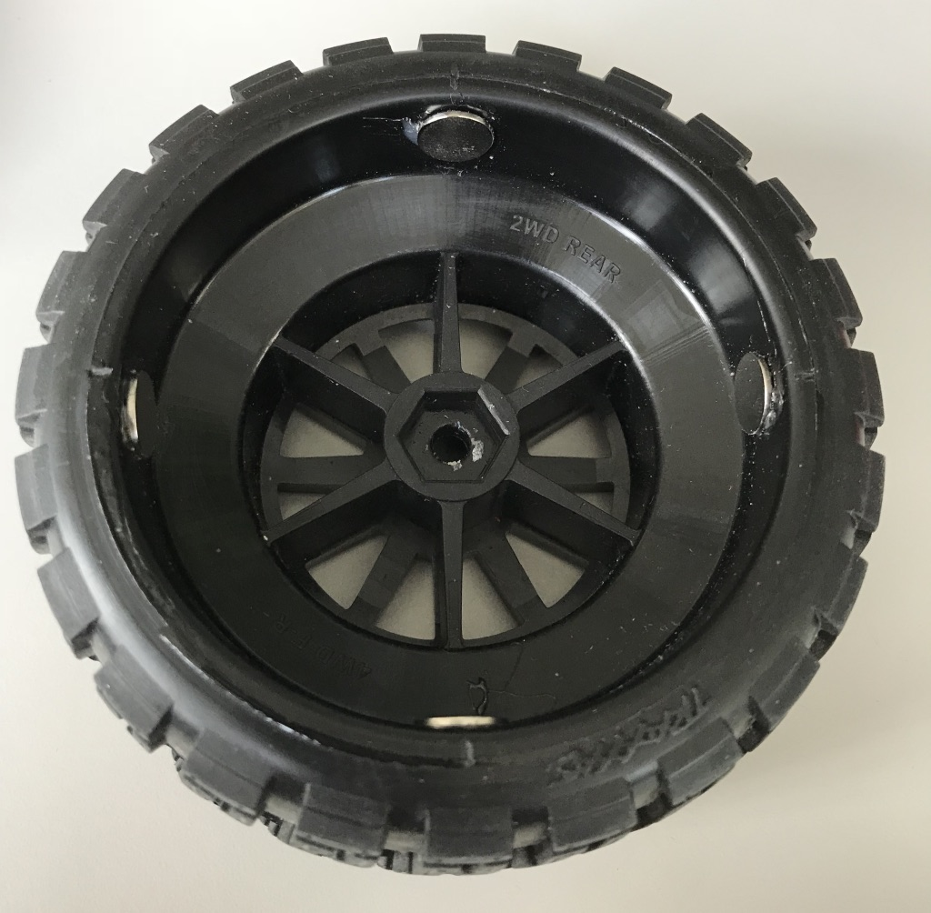

**Buck converter (to power the Odroid from the car battery)**

The following buck converter instructions are copied from the original BARC installation manual. To see the original manual in full, please navigate to the following document: [Original BARC Manual](Original%20BARC%20Manual)

Steps 1-4 illustrate how to install the Anderson powerpole connector in general.

1. Strip off about 8-10mm of insulation from a piece of 14-18 AWG wire.

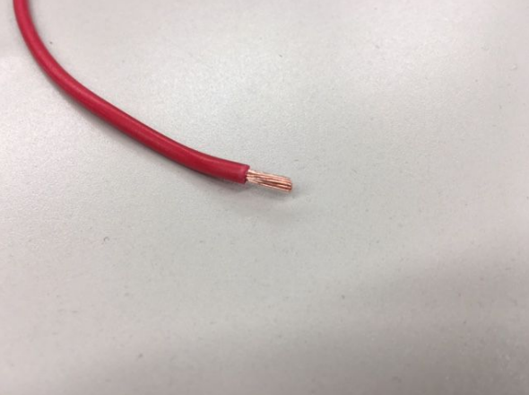

1. Insert the silver insert into the Anderson powerpole crimper, then the stripped wire into the insert piece. Squeeze the handles, which will ratchet-lock until proper pressure has been applied, at which point they will release and spring open.

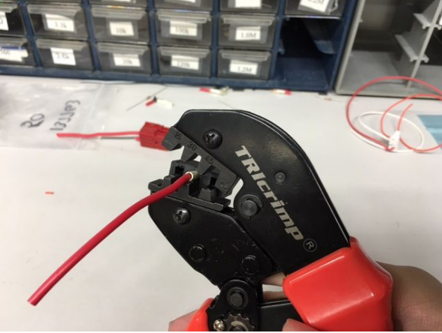

1. The crimped connection should look like this. If you don’t have a crimper, you can also solder the wire into the insert.

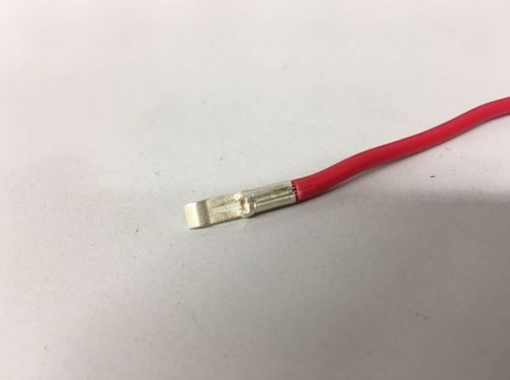

1. Push the insert into the back of the housing, until you hear a click. A small screwdriver can help you apply force on the insert rather than the wire. After the click, you should not be able to pull the wire out of the housing with bare hands.

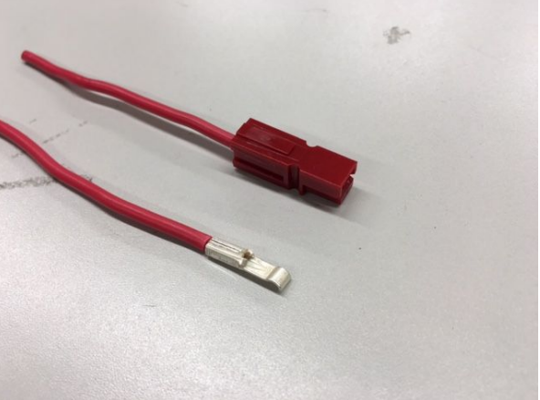

1. Splice the power cables on the ESC in the place shown (orange). To splice the wire, cut off a piece of insulation on the ESC power wires, tin the wire with solder, and solder another wire to it. DO NOT cut the wire, you are simply removing a section of the wire covering. After the splice, wrap that area with electrical tape. The spliced leads will be the input to the buck converter. You can attach Anderson connectors to them using the procedure shown above. Note that you can bind individual Anderson housings together using the tab and slots on the side of the connectors by sliding them into each other (blue).

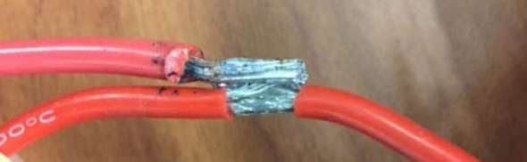

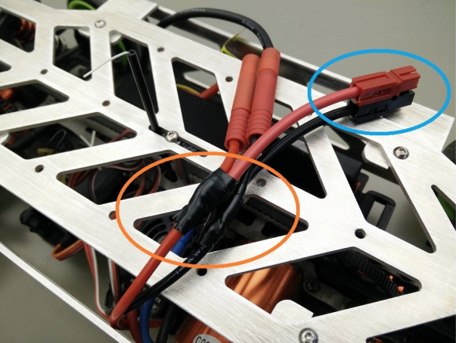

1. Install Anderson connectors on the INPUT side of the buck converter (yellow). Solder the “barrel-jack to open leads” cable to the OUTPUT side of the converter (green). Beware of polarity.

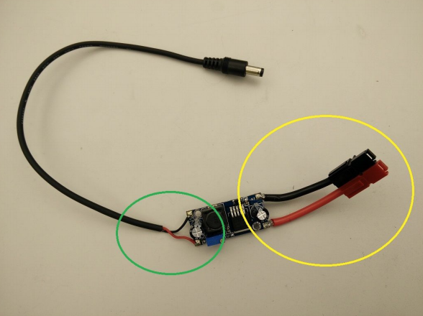

1. Adjust the screw on the potentiometer to trim to output voltage to 5.15V (as close as you can, but do not exceed 5.20V). You MUST ​do this before powering on the Odroid for the first time. It is advisable to check the output every time you power the Odroid.

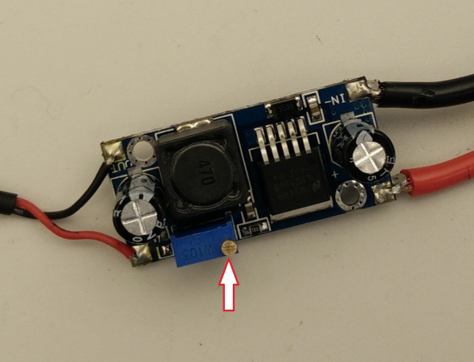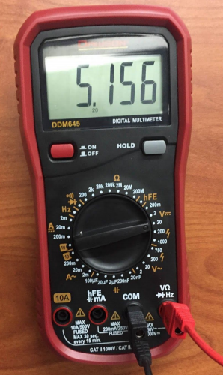

1. Insulate the board with electrical tape or other materials of your preference.

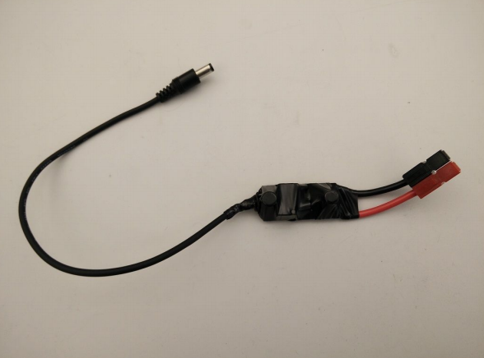

**Mount deck**

The mount deck is the mounting point for the Odroid, USB hub and the ZARC PCB which holds the Arduino and IMU. Before you secure the mount deck to the car, please perform the following steps:

**Secure Odroid to the mount deck**

Required hardware:

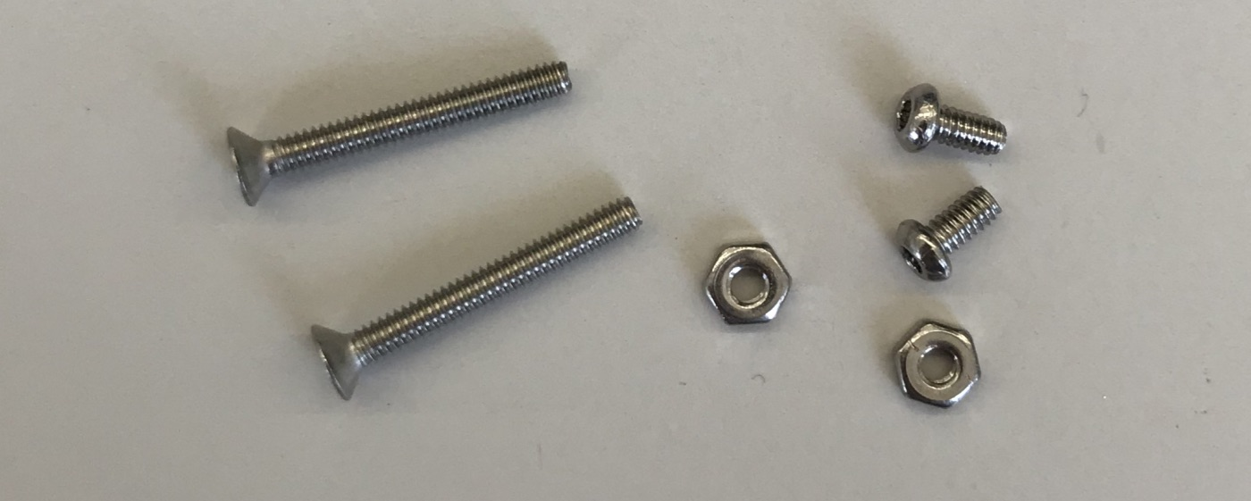

2x m2x16mm screws

2x m2x3mm button head screws

2x m2 but

1. Mount the Odroid case to the deck using the two m2x16mm screws and m2 nuts as shown below.

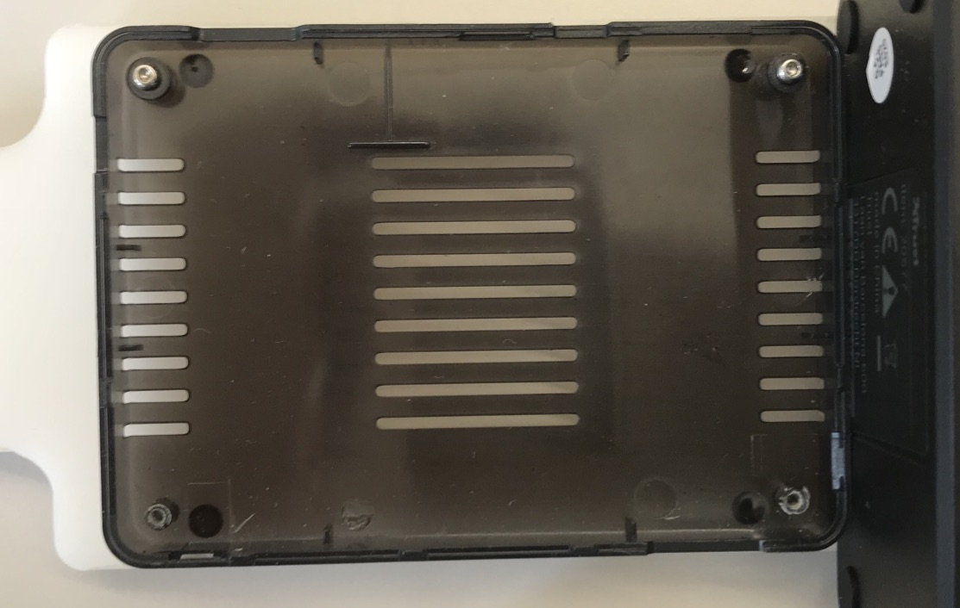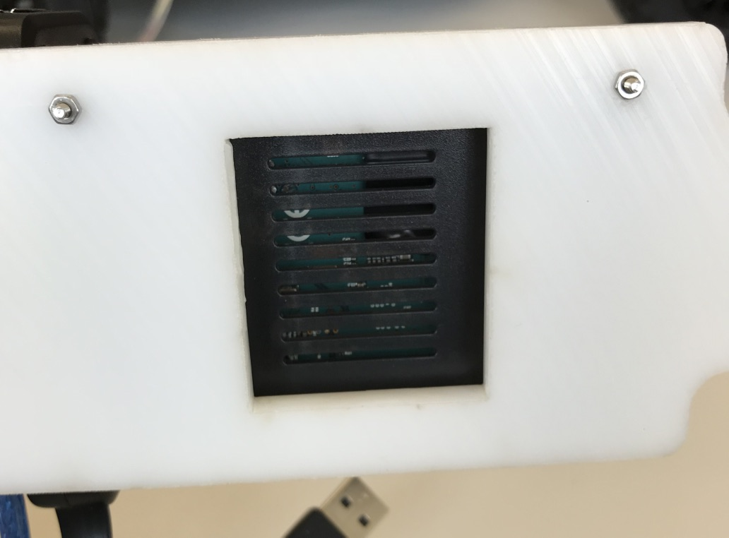

Top and bottom views, respectively of the Odroid case secured to the deck

1. Mount the Odroid onto the case with the two m2x3 screws as shown below.

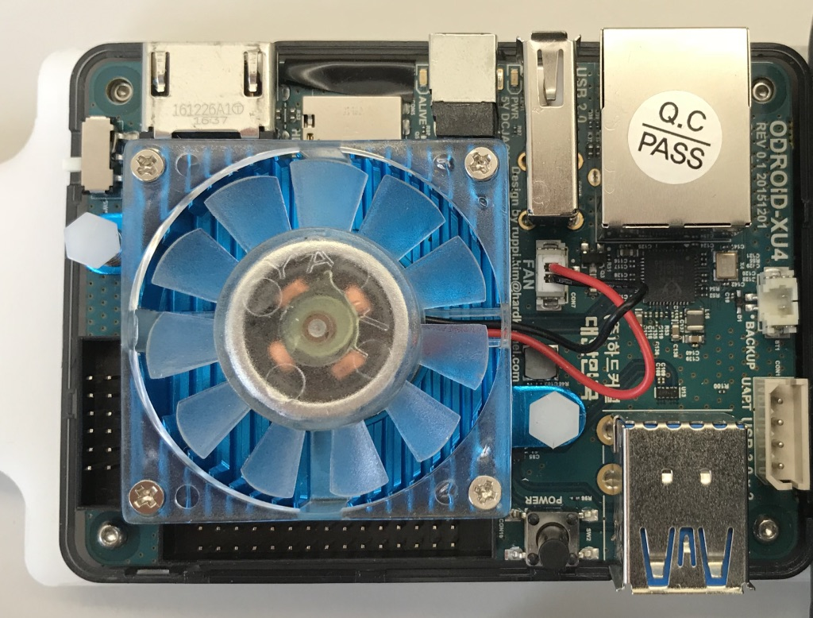

1. Feed the clock cable through the top portion of the Odroid case and plug in the clock battery into the socket referenced to by the red arrow in the figure above. Ensure that there are no obstructions in front of the Odroid’s cooling fan.

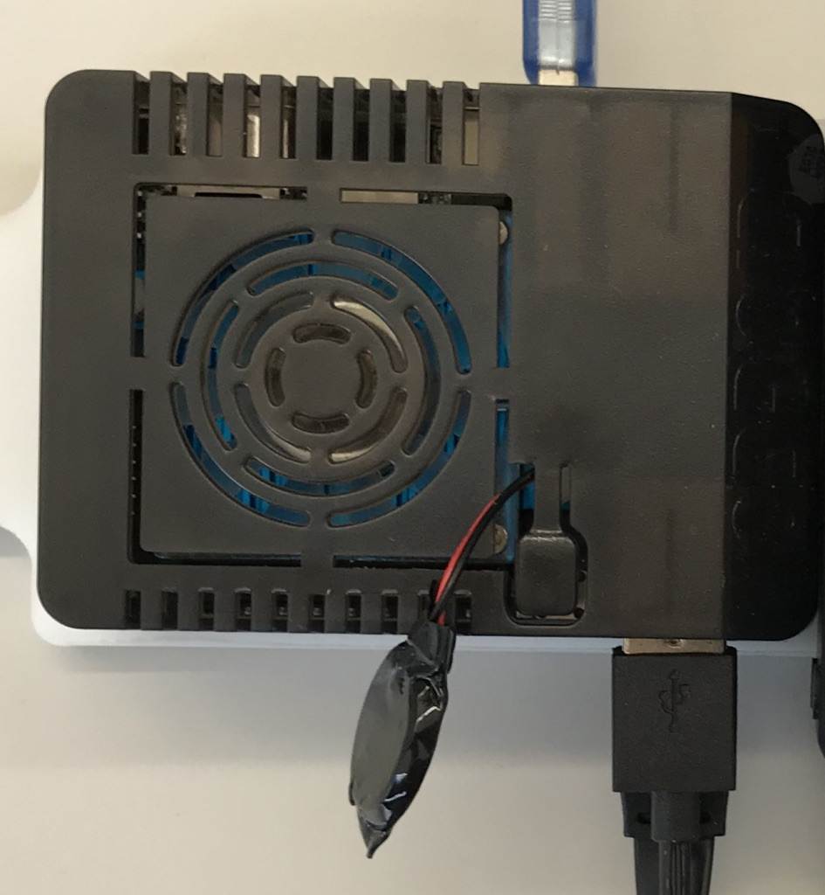

**USB hub to mount deck**

1. The USB hub is secured to the mount deck via double sided tape as shown below.

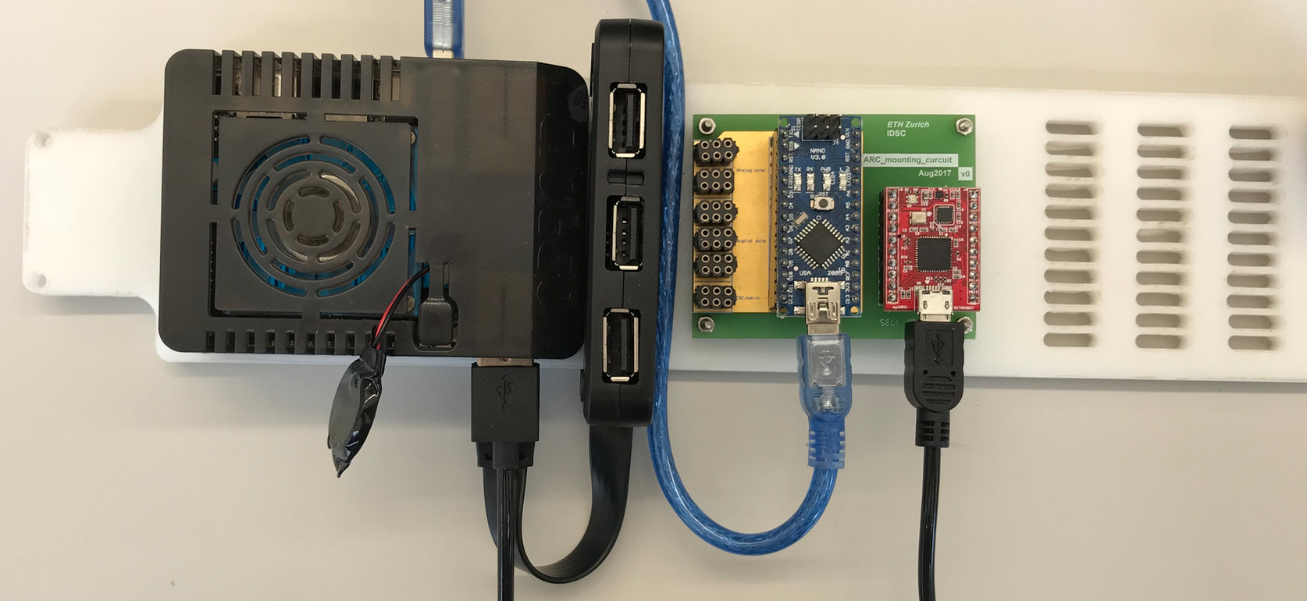

**ZARC PCB to mount deck**

Required hardware (x4):

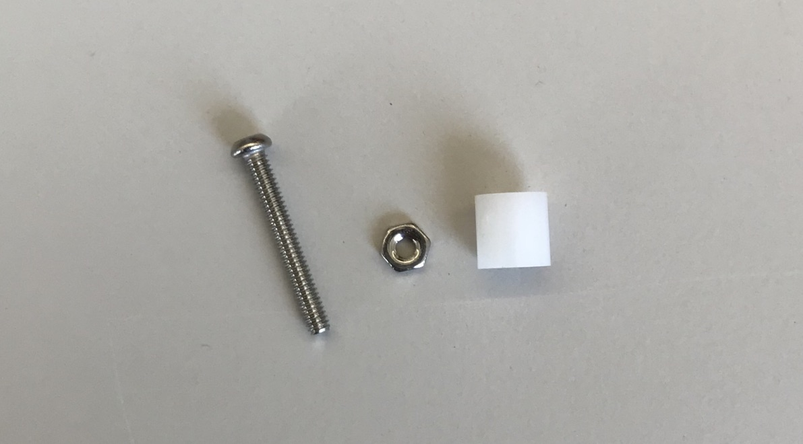

4x m2x16mm button head screw

4x m2 nut

4x 5mm plastic spacer

1. Mount the ZARC PCB using the four m2x16mm button head screws (threaded upwards as shown) and matching m2 nuts. In between the mound deck and PCB, place the 5mm plastic spacers as shown below.

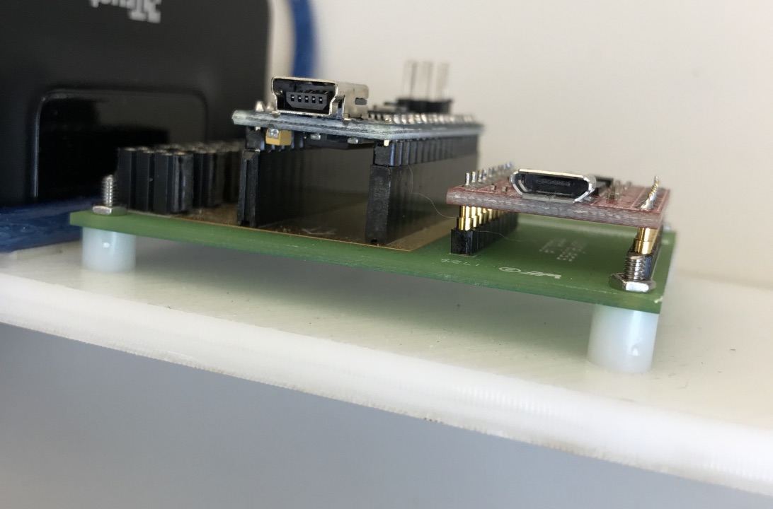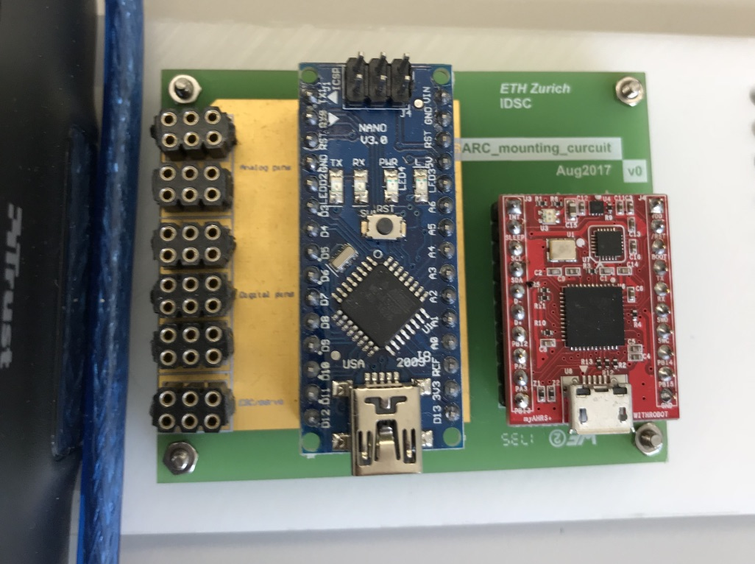

**Mount deck to chassis**

Required hardware:

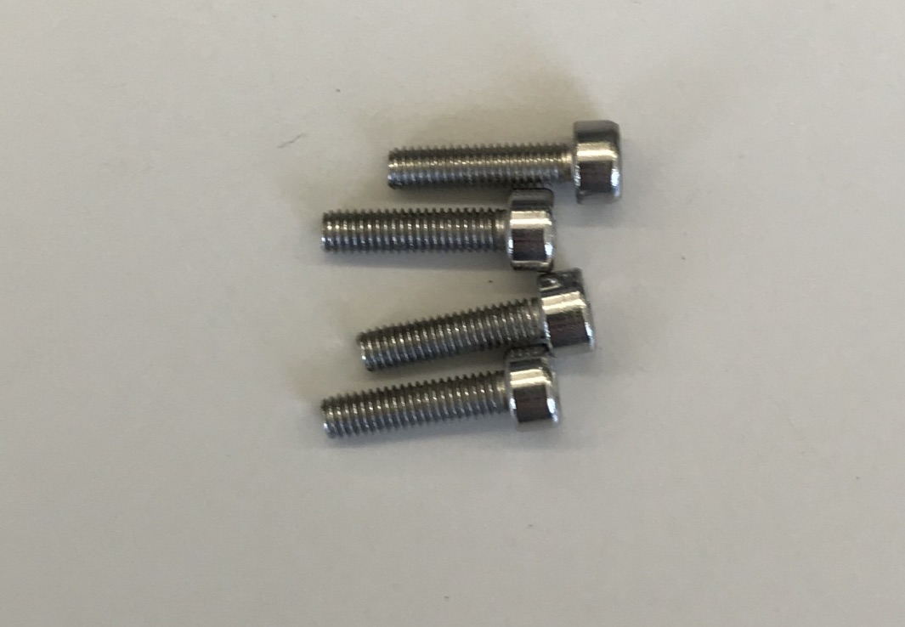

4x m3x12 screws

1. Install the mount deck using the four m3x12mm screws as shown below.

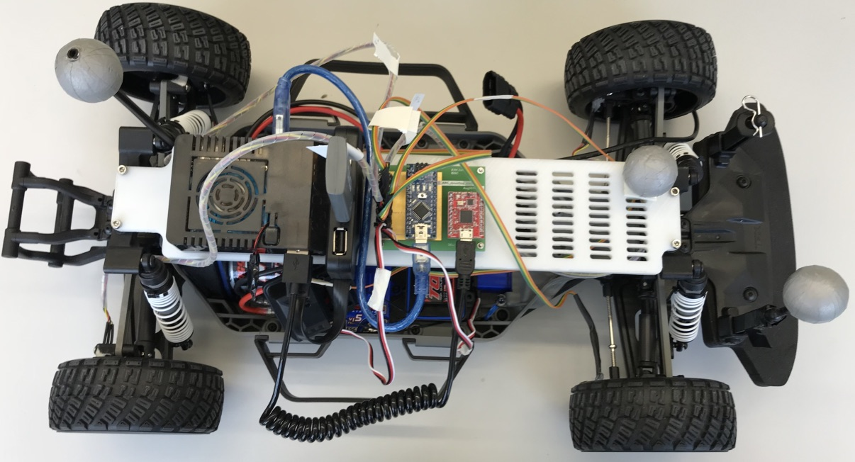

**Final Steps**

Lastly, connect the Odroid to the Android and IMU via USB. Plug the two WiFi adapters (module 3 and module 5) into the USB hub. One WiFi adapter can be used to connect to your network while the other can be used to create a dedicated network, to which you can connect to via your laptop. For detailed instructions regarding connecting up the wheel encoders and other necessary instructions, see “Electrical Assembly” below.

**ELECTRICAL ASSEMBLY**

In order to connect the Arduino to the correct sensors and inputs/outputs, the following Arduino graph is referenced. Note that the following images can also be found in the original BARC repository:

<https://github.com/MPC-Berkeley/barc/tree/master/arduino>

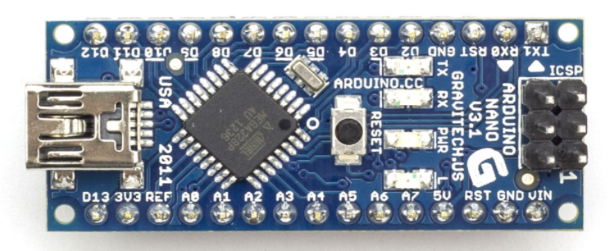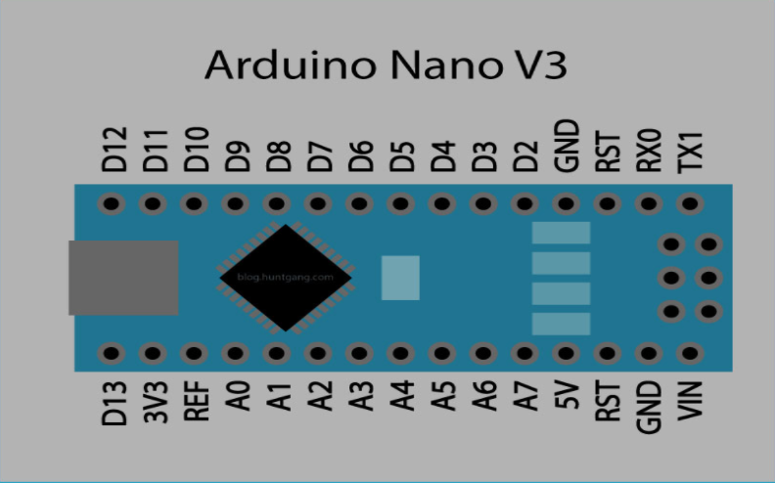

In order to understand the pin layout of the custom ZARC PCB, please see the image below.

TODO: ZARC PCB pin-out

The following pin assignments should be followed:

|  |  |
| --- | --- |
| **Component** | **Pin** |
| Front Left Encoder | D2 |
| Front Right Encoder | D3 |
| Back Left Encoder | D5 |
| Back Right Encoder | D6 |
| Throttle (from RC receiver channel 2) | D7 |
| Steering (from RC receiver channel 1) | D8 |
| Electronic Speed Control (for 3-phase Motor) | D10 |
| Servo | D11 |

If you desire to include the RC receiver “in the loop” (ie use the factory RC controller to control the car and manipulate input RC signals via ROS), pins D7 and D8 must be utilized according to the chart above. In order to connect the Arduino to the corresponding channels from the RC receiver, two custom cables as shown in the image below were constructed. The cables are constructed as simple male to female connectors: the female end secures to the RC receiver unit while the male end connects to the Arduino at the corresponding pin (see chart above). Lastly, the soldered ends of the custom connectors are covered with heat shrink tubing.

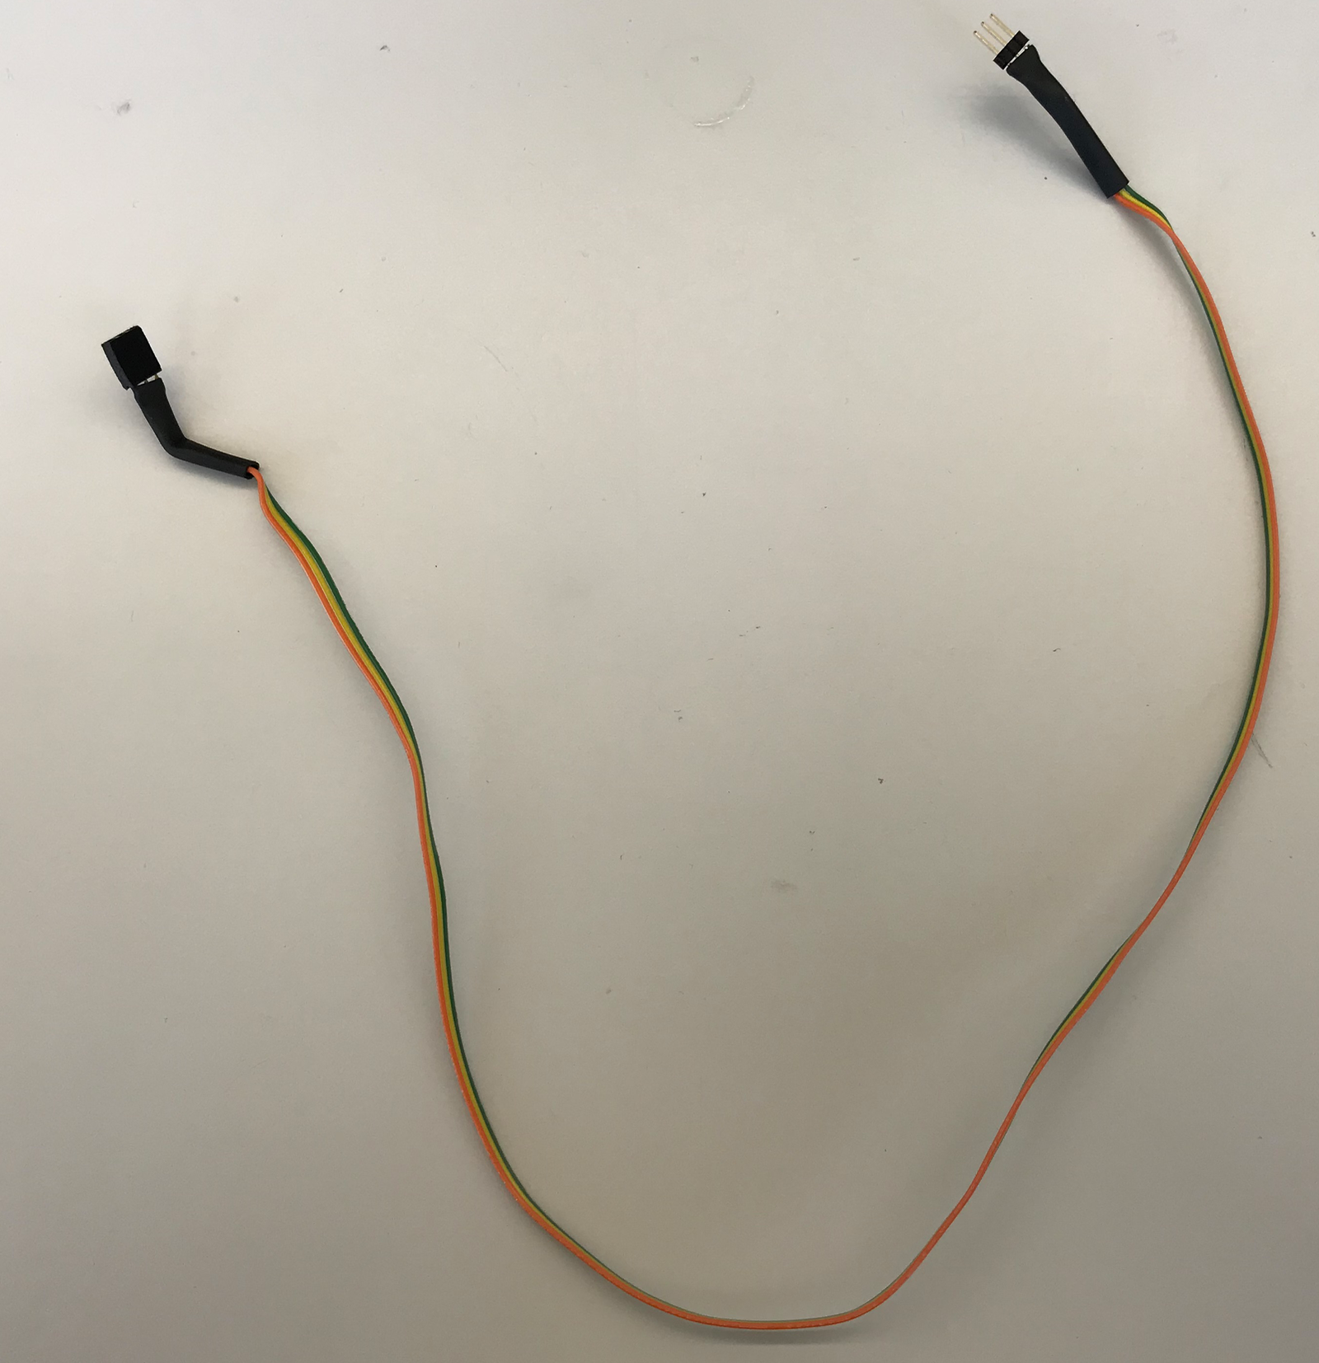

**CONTRIBUTORS**

This guide was developed by the following contributors:

Brett Stephens (IDSC student project)